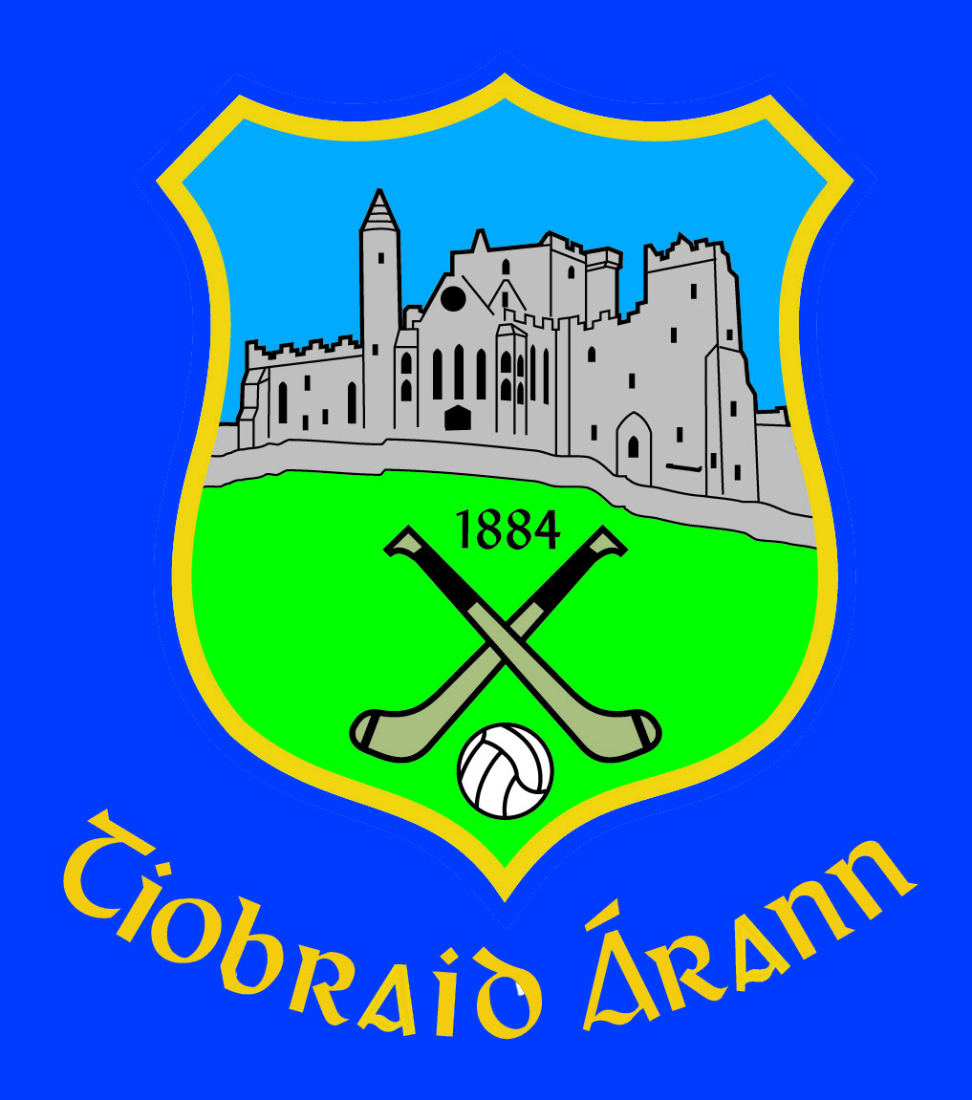Scoláireachtaí Gaeltachta 2018 Foirm Iarratais

Name / Ainm ______________________________________________

Boy / Buachaill  Girl / Cailín  Date of Birth / Dáta breithe: __________________

Adress/Seoladh __________________________________________

__________________________________________

__________________________________________

Name of Parents / Guardians (Ainmneacha Tuismitheoirí / Caomhnóiri)
1 __________________________

2 __________________________

Phone / Fón Home :____________Parents Mobile :_________________

Name of School / Ainm na Scoile: _______________________________________

School Year / Bliain i Eanair 2018: _______________________________________

Ainm do Chlub:______________________________
(Name of Club) _______________________________________________________________________________________

- Enter X in college of your choice below.

- Port Lairge/Coláiste na Rinne 2. Ciarraí/Coláiste Corca Dhuibhne

- Corcaigh / Coláiste Na Mumhan (Scholarships only granted for Munster Colleges).

The applicant will be asked to attend an interview and if successfull the scholarship grant will be paid out once a receipt for fee payment to one of the colleges below is returned to An Rúnaí, Choiste Chontae Thiobraid Árann.

These scholarships are confined to 2nd Year, 5th Year and TY Students in 2018 and previous recipients of Tipperary GAA Gaeltacht scholarships cannot apply in 2018. Only one scholarship per family allowed.

Síniú Rúnaí an Chlub _________________________________________________________________
(To be signed by the G.A.A. Club Secretary who must enter the applicant’s membership number below)
(The club secretary must also attach a letter of reference supporting the applicant’s club involvement)

Uimhir Ballraíocht CLG______________________(GAA Membership No of Applicant or Parent/Guardian)

This completed form must be returned to An Rúnaí, Coiste Chontae Thiobraid Árann, Lár na Páirce, Dúrlas, Co. Thiobraid Árann before Fri Feb 2nd 2018. Late applications will not be considered.

Applicants will be interviewed around end of February. Cuirfear na hiarrthóirí uile faoi agallamh.

